Happy New Year, Eswood families & Community! I hope you have had a wonderful, relaxing Winter break!!!

Second quarter was filled with rich educational experiences. Our middle school students worked to reach their accelerated reader goals and attended Flow Supreme Air Sports as an incentive for reaching their individual goals. The entire school was able to attend the Nutcracker at the Coronado in Rockford, getting us all ready for the holidays. Our Boy’s Basketball finished their season right before break, we held our Winter Art’s Night to showcase all our wonderful artistic talents, Community Club hosted Cookies with Santa, the Fire Department came and presented fire prevention to the Elementary side of the building, and so much more! We had a really great second quarter and the students were highly engaged, learning and having fun!
December 20th, 2023 we said goodbye and good luck to longtime staff member, paraprofessional Lynne Jokers as she heads off into retirement. Mrs. Jokers has served our community for over 20 years helping educate our students and served in and took care of our library over the past years. During our Art’s Night, Community Club recognized Mrs. Jokers for her service with the addition of her name and years added to our staff plaque that will be housed at Eswood to represent the time she spent with us! Thank you Mrs. Jokers for your time and service to Eswood Elementary School and the community of Lindenwood, IL. If you see her, please take the time to thank her for all her hard work and dedication for our students.
Nolen Schweitzer won first place in the VFW’s essay contest this fall and his essay is headed to District, hoping to win and then be sent to State!!! WAY TO GO, NOLEN!!!!
Our Girl’s Basketball team starts practice and games here mid-January with a new coach. Coach Morrsette and the team will begin their season Tuesday, January 23rd, 2024 at Cornerstone with our first home game Tuesday, January 30th against Creston. Our other girl’s basketball home games will be February 8th, 13th, 20th & 22nd, with tournament play at King’s School February 27th-29th, 2024. Please come out and support our team!! GO LIONS!!!
A few reminders about upcoming school events. Parent/Teacher conferences February 7th and 8th from 3-7pm. As we get closer to these dates, teachers will reach out to extend a time to meet with you if they need to conference with you, but as always, if you are wanting to meet with a teacher, please feel free to call the office to set up an appointment. We host a girl’s basketball game on that parent/teacher conference Thursday, February 8th, so maybe come to conferences and then take in a game!
Upcoming NON school days: Monday, January 15th, Friday, February 9th, Monday, February 19th, Monday, March 6th and Eswood’s Spring Break is March 25th-29th, with Easter Monday OFF on April 1st, 2024.
IAR testing will happen for grader 3-8th this Spring (Dates to come soon), with some fun activities leading up to the testing!! We will also be asking staff, students AND FAMILIES to complete a 5 Essentials Survey that will help us move forward with our continuous improvement process for Eswood CCSD. We want YOUR INPUT on what we are doing well AND where you see our areas for improvement!! More information coming soon on how to complete your survey. Our Illinois Science assessment for our 5th and 8th graders will be held after spring break.

Thank you again for allowing us here at Eswood School the privilege of educating your children!!! We have an amazing staff and great community support. We hope you feel the love from our staff and we hope you can see how hard we are all working together for YOU and your family!!!

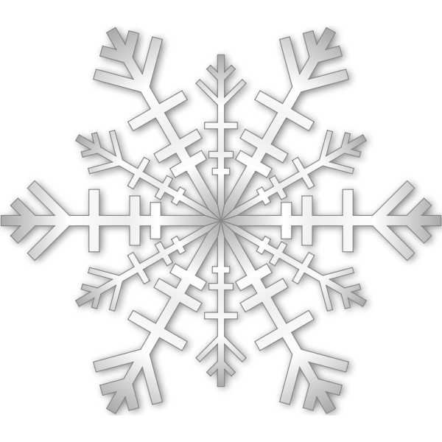
Enjoy the winter months, please reach out with any questions or concerns!
Sincerely,

Kirsten Garrigan
District Superintendent
Eswood CCSD 269
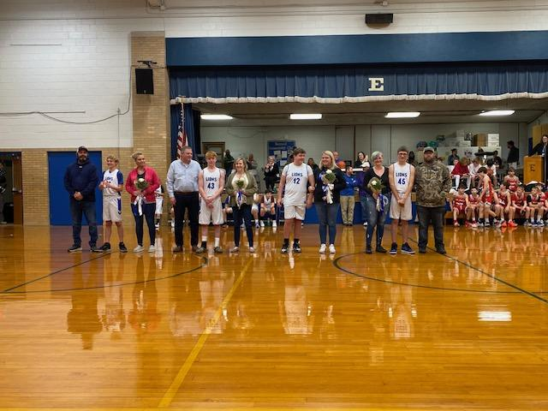
8th Grade Night: Boy’s Basketball: Coach Winters

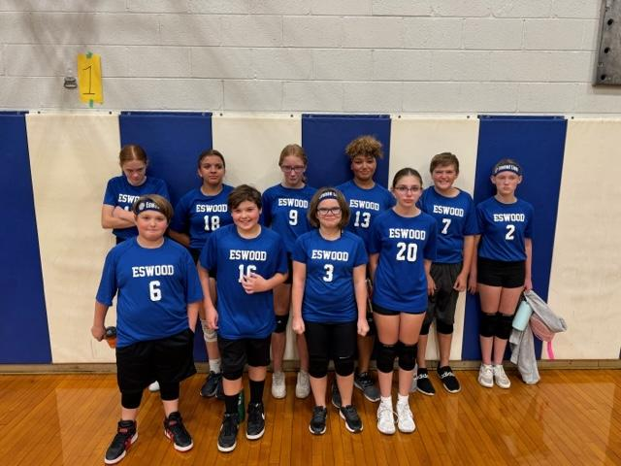
Volleyball Team: Coach Patti Price
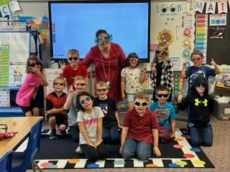
Mrs. Reed’s First Grade: Sunglasses Spirit Day
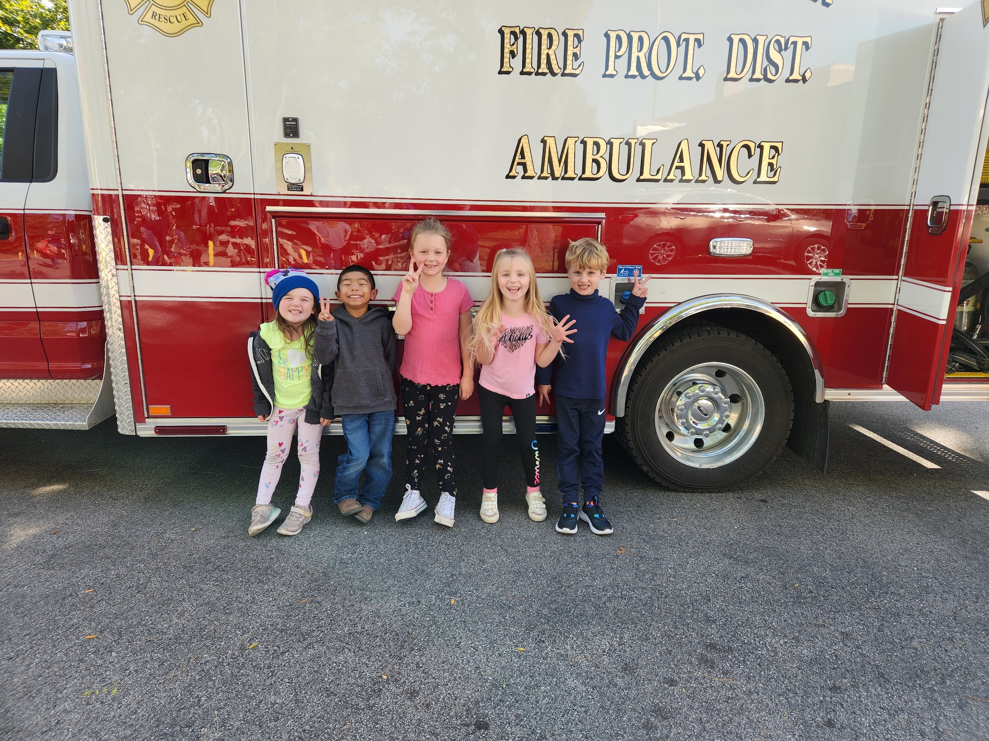
Mrs. Roger’s Kindergarten: Fire Prevention Presentation

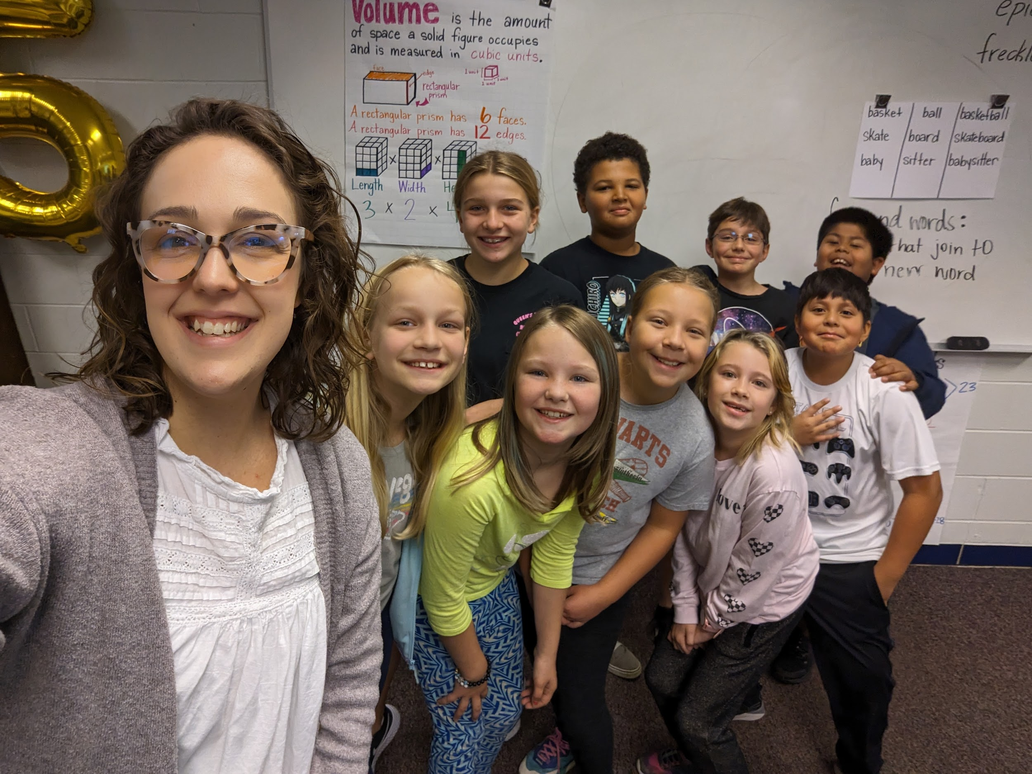
Ms. Dobson’s 5th Grade Class

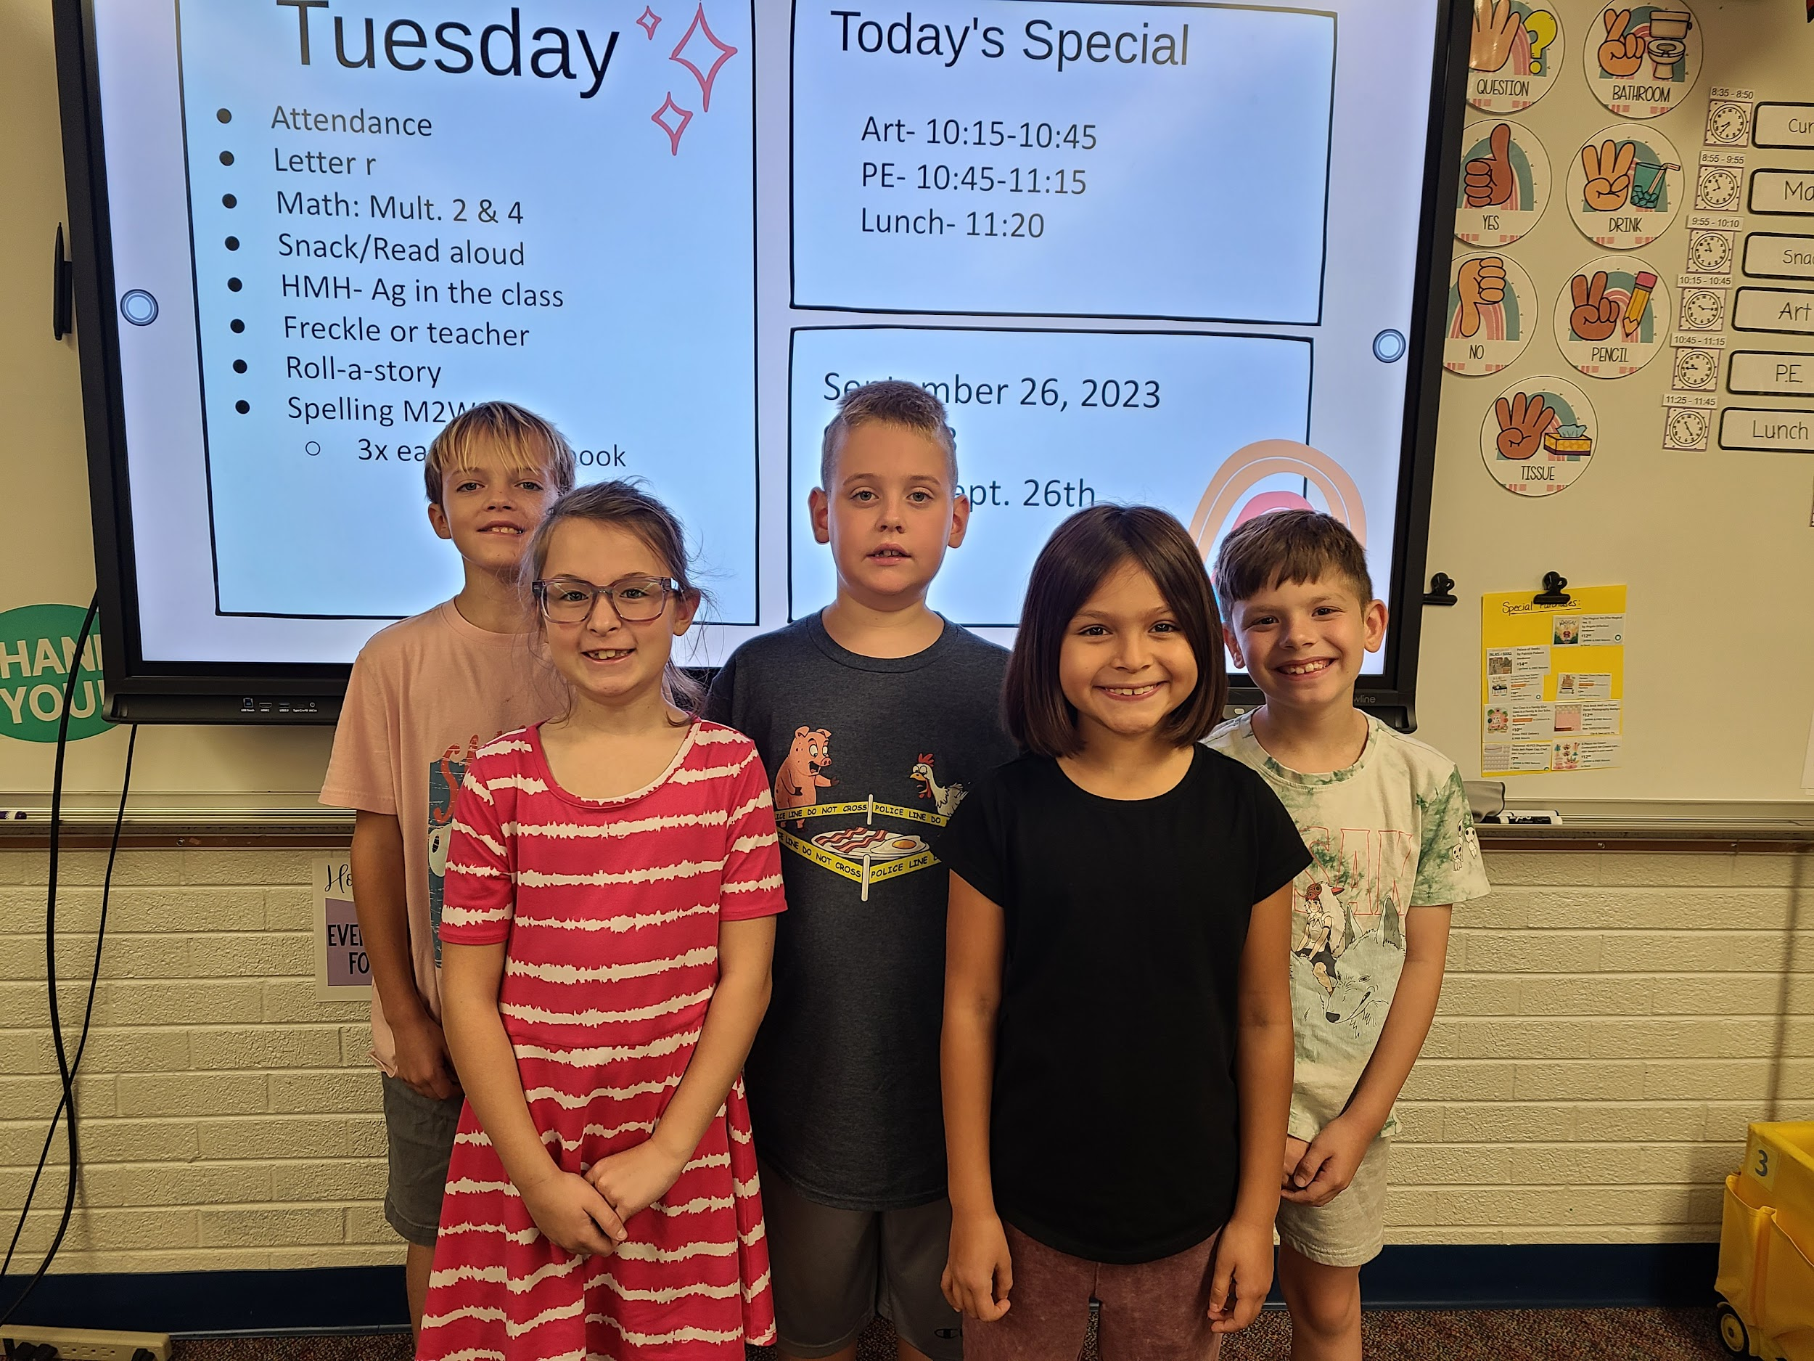
Mrs. Bell’s 3rd Grade Class
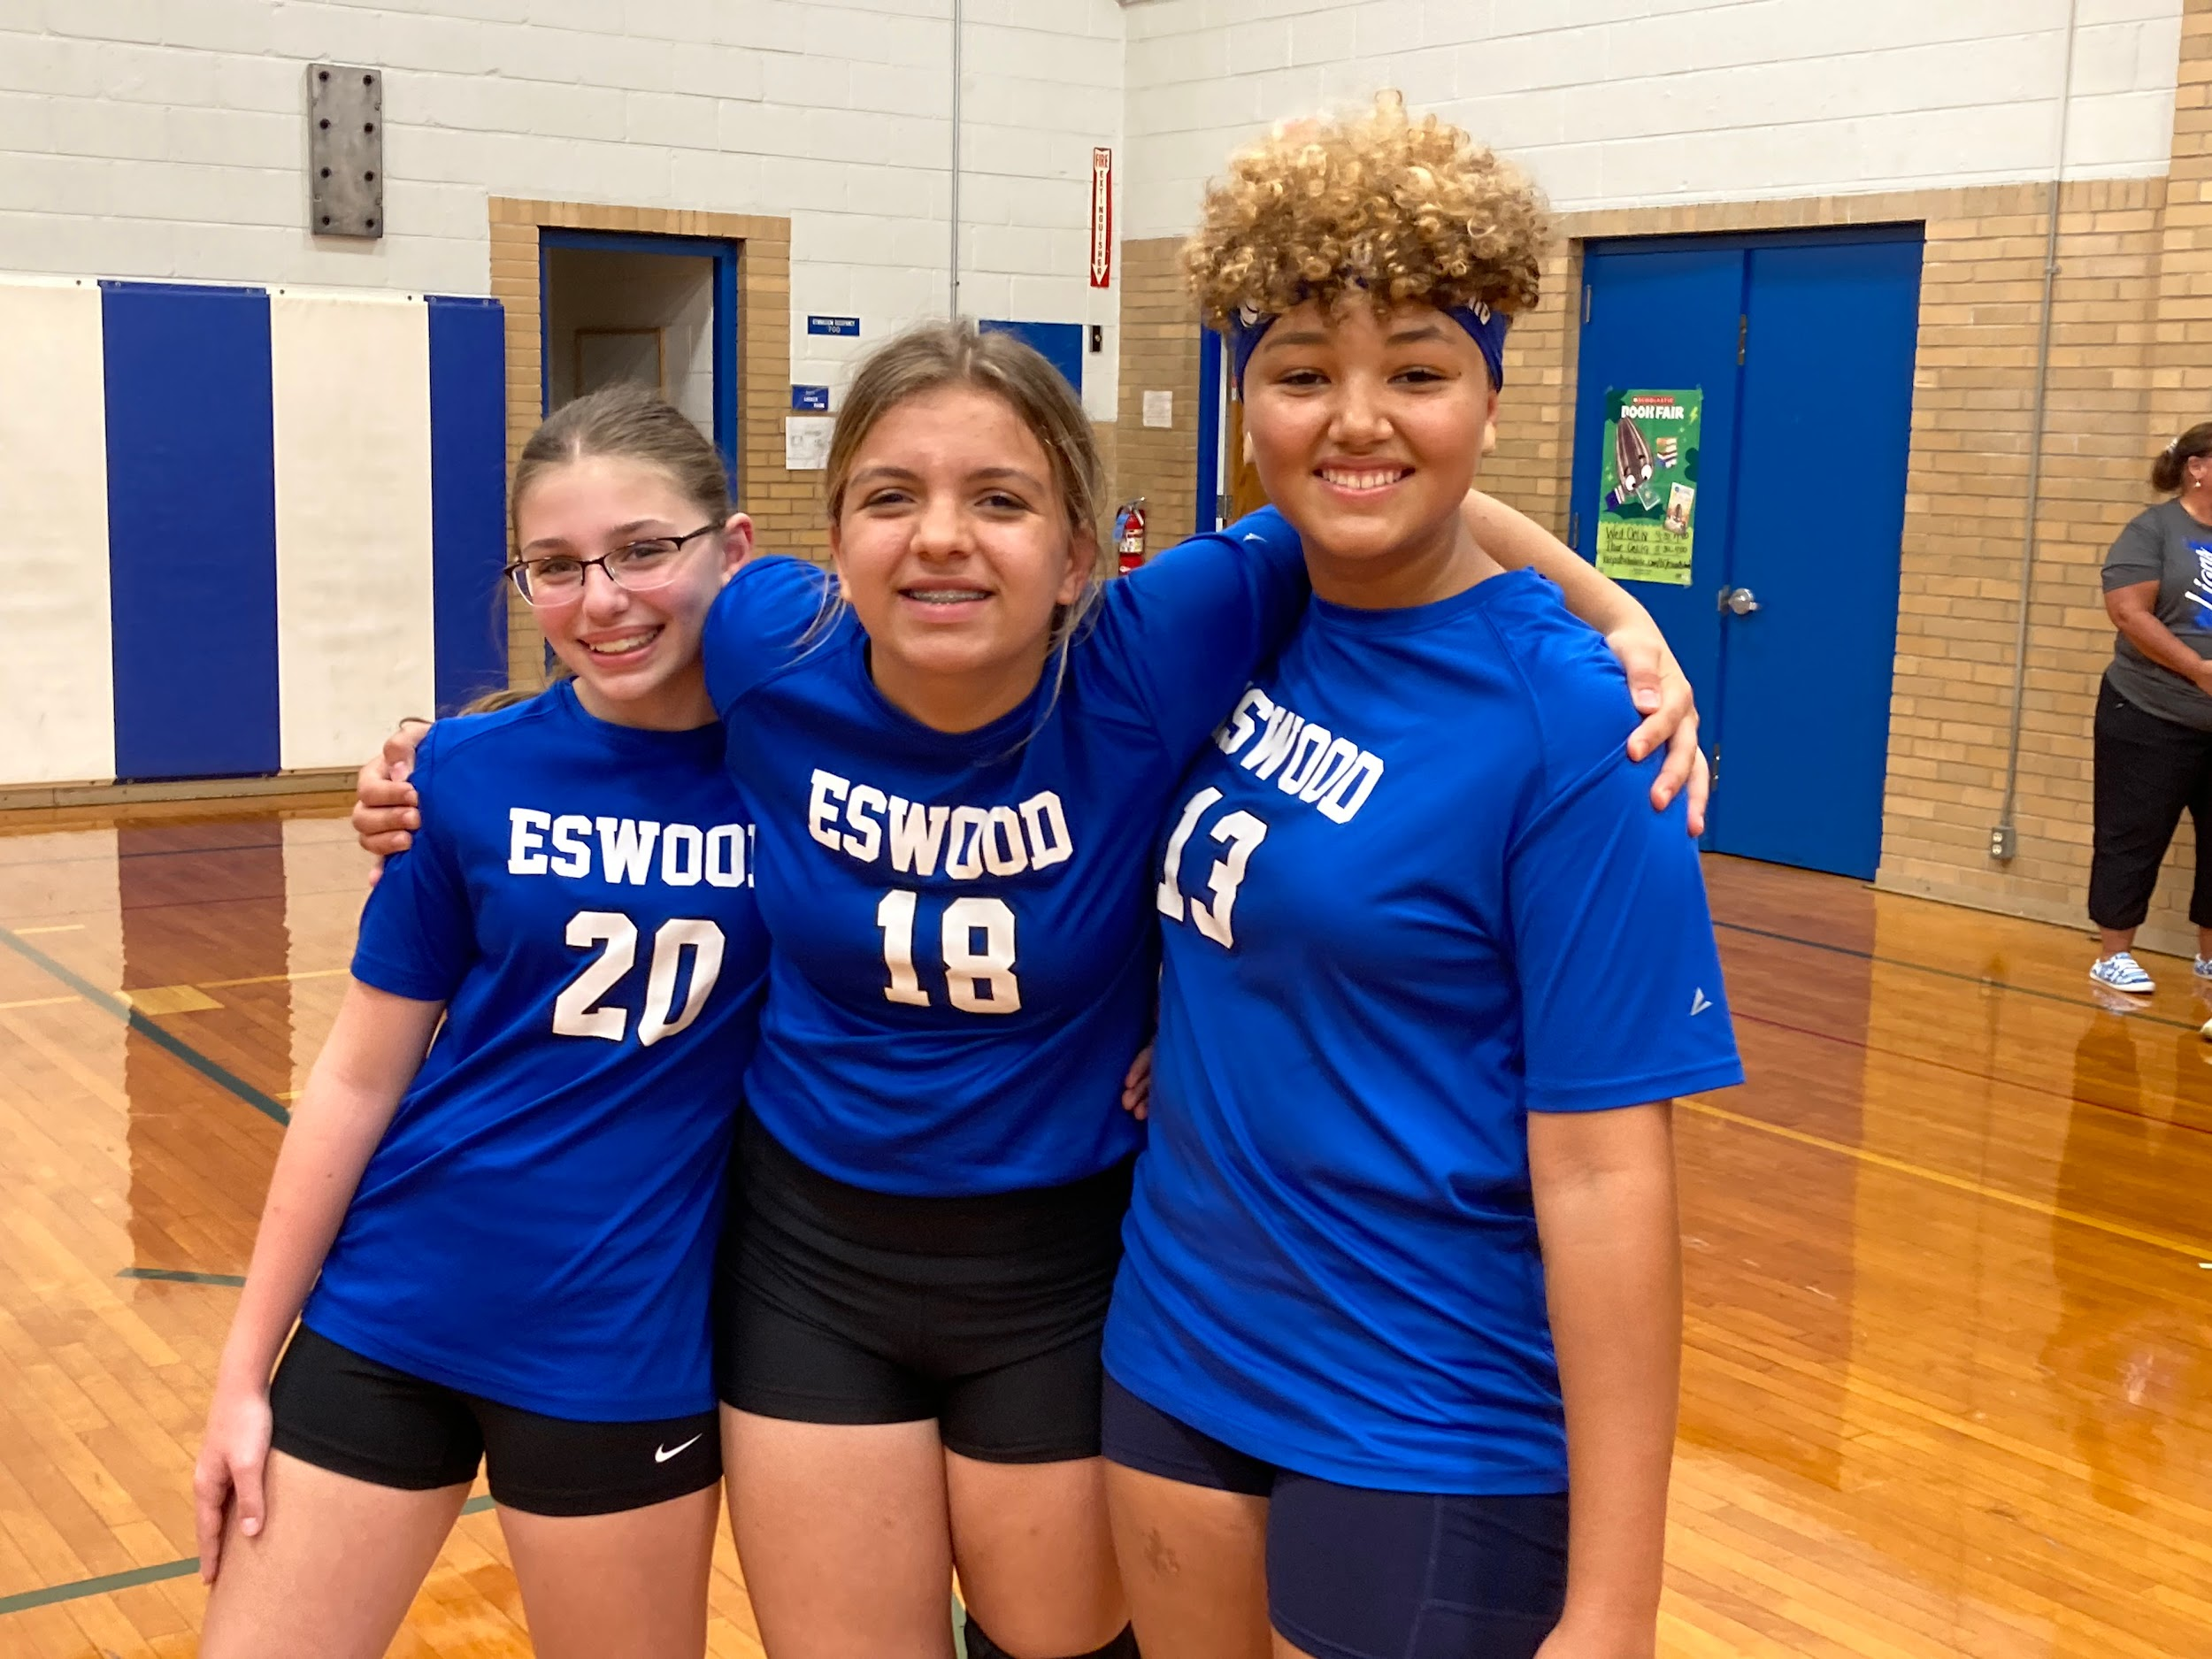
8th Grade Night: Volleyball 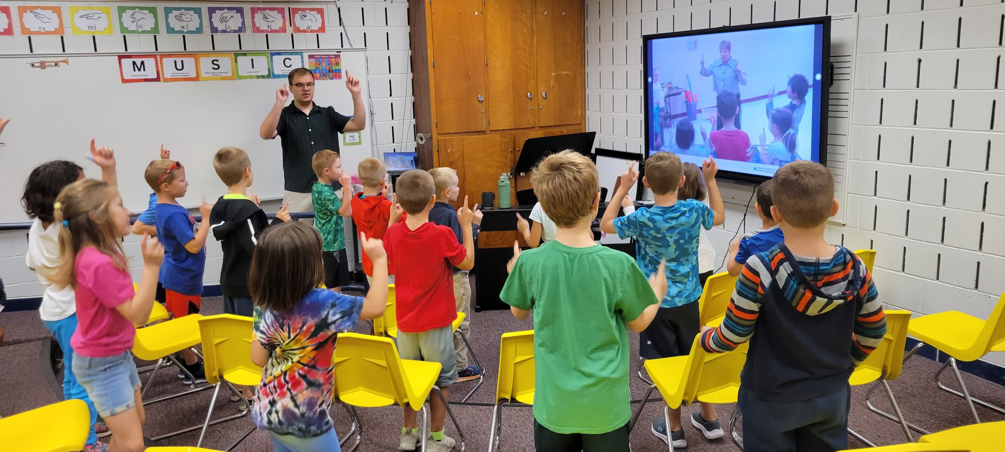 Elementary Music Class: Mr. Groth
Mrs. Rogers- This school year is going by fast! It’s hard to believe that quarter 3 has begun! The kindergarteners continue to amaze me with their hard work and academic growth!
A majority of quarter 2 in math was spent working on addition and subtraction. They started with adding and subtracting within 5 and then recently have been working on addition and subtraction within 10. In phonics, students have been continuing to learn their letter sounds and blending sounds together to read words. They have also started to practice sounding out words to write complete sentences. In reading, students have been learning more new sight words. The students have come so far in the first half of the school year and I am so excited to see their growth during the last half of the school year!

Mrs. Reed - First Grade has been busy this quarter learning new phonics sounds and rules like digraphs, blends, and the silent e. We have been implementing it into our daily writing and reading practice. First grade students have been practicing retelling stories both orally and in writing, as well as identifying the characters, setting, problem, and solution of a story. At Thanksgiving, we completed procedural writings explaining how we would build a “turkey trap” and use it to catch a turkey. In December, we read several versions and variations of the classic Gingerbread Man story and compared and contrasted them using a Venn diagram. In math, we have learned all about data and how it can help us solve problems. We collected all kinds of data and put it into tally charts, bar graphs, and picture graphs. At the end of the quarter, Mrs. Reed’s class also enjoyed a special Polar Express Day where we read the classic book and retold the story, complete with our favorite pajamas, stuffed animals, popcorn, and hot cocoa. We are looking forward to the second half of the school year and all of the new things we will learn!

Miss. Hosick - Hello from second grade!
We have just wrapped up quarter 2 and it has been filled with a lot of holiday fun. We have had fun exploring math, reading, writing, science, and social studies together. Here is a glance at just a fraction of what we have covered!
Math - During math we practiced our fact fluency with fast facts. We also were adding and subtracting two digit numbers with regrouping.
Reading - We did a book study on the story Reindeers do Wear Striped Underwear by Marcia Thornton Jones.
Science - During science, we studied reindeers and some of their adaptations.
Social Studies - In social studies, students have learned about a variety of winter holidays that are celebrated in different countries. We did a lot of traveling!

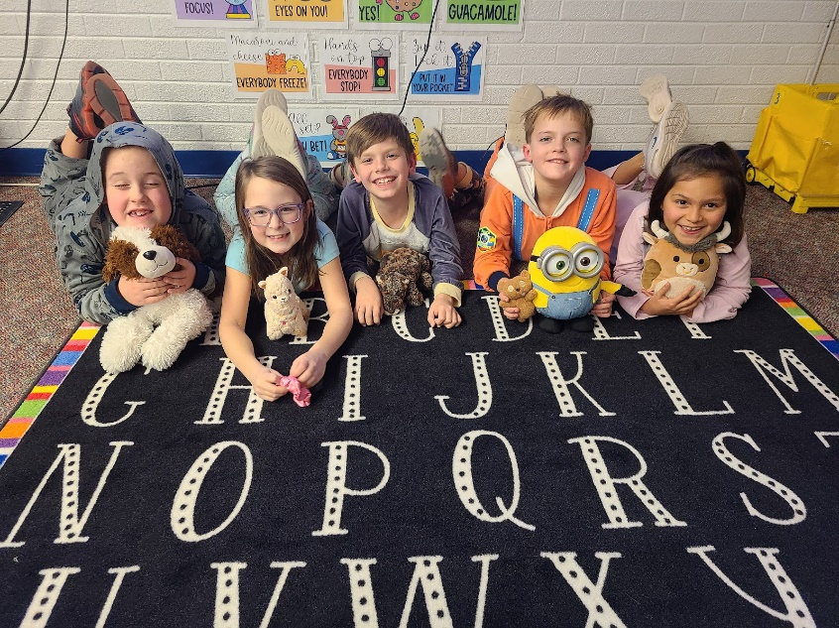
Mrs. Bell - Quarter 2 was exceptional! There was a lot learned and fun had. We finished up our multiplication unit with a fun room transformation to review all that was learned. The students got to enjoy circus themed centers and treats. Our class also enjoyed the holiday parties and a class reward they earned. We had class visitors from 4-H and the U of I extension AG in the class lessons. We spent time learning about reading maps, the pilgrims, and Christmas in different countries. The kids had fun writing their own stories then letters to santa. These kids have learned and grown so much in this short time. I can’t wait to see what they continue to do!

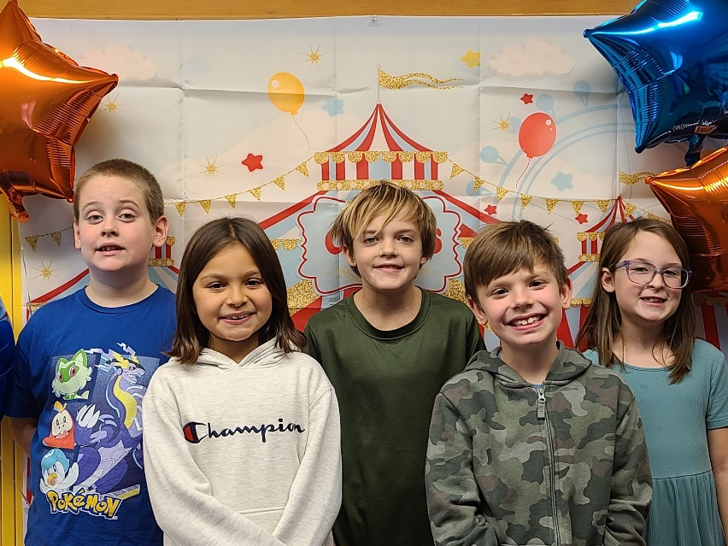

Mr. Larson - 4th Grade continues to do great work! Everyone showed tremendous growth on our recent Star Test, in both English Language Arts and Math. Creative Writing remains a strength and a passion for everyone. The imagery and word choice has been nothing short of AWESOME!!!! We are about to begin fractions in Math and I expect great things. As readers, 4th grade is hitting all their AR goals and getting into higher level thinking skills in their written responses. Happy NewYear and on towards Spring!

Ms. Dobson - Hello from fifth grade! Second quarter and 2023 have drawn to close, and we are excited to start the new year.
Our brains have been full of fractions. We gained mastery in generating equivalent fractions with common denominators and converting between improper fractions and mixed numbers in order to solve addition and subtraction scenarios with unlike denominators. We have also worked on multiplying fractions, and as we return to break, we are going to extend that knowledge to multiply mixed numbers. Whether we need to add or subtract fractional distances or determine the total cups we need for a recipe, we are ready for it!
Our ELA modules explored the following essential questions:
- How can learning about natural disasters make us safer?
- What character traits were needed in people who settled the West?
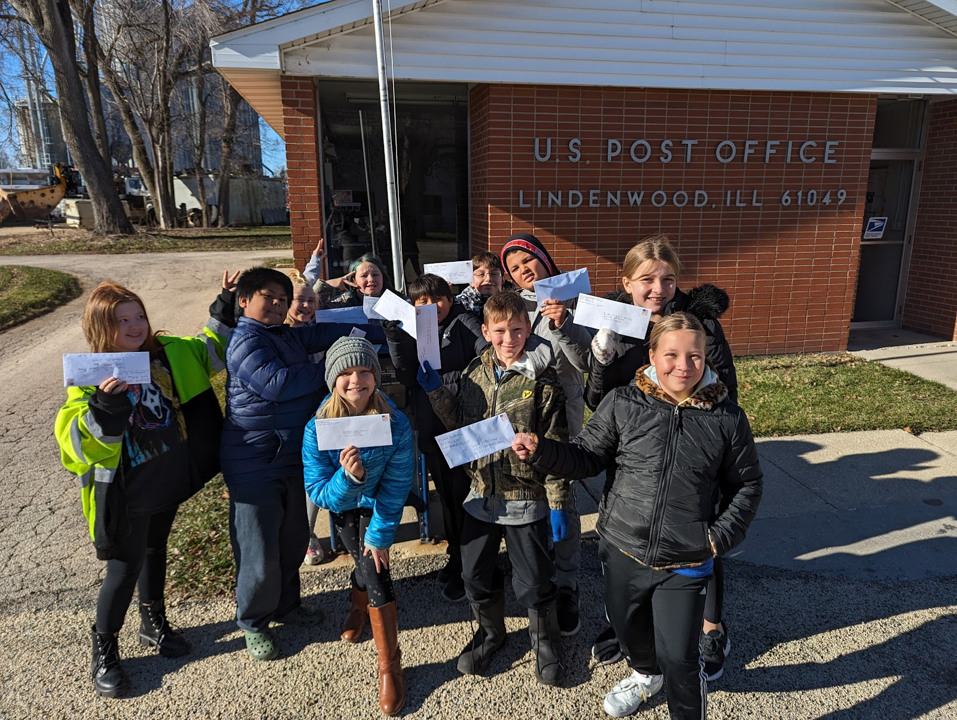
We read many different texts, and some of our favorites were Eruption! Volcanoes and the Science of Savings Lives and Explore the Wild West!. We even ventured our own way down to Oregon Trail in a simulation. The students quickly learned the many decisions pioneers faced and just how deadly some proved to be. We wrote formal letters to a few historical societies and museums asking for more information about westward expansion (pictured below), and some of the students have already received a response! In Social Studies, we learned about various economic systems around the world and how they interact with each other. We were excited to have a visit from Ag in the Classroom and apply what we had learned about supply and demand to agribusiness. We finished the quarter learning about personal finance and the benefits of having a budget.

Mrs. Tofte (5-8 Grade Science, 6th Grade Math)-
Hello Eswood Community and Happy New Year! I have an exciting update on the middle school students' academic journey, and I am thrilled to share some highlights from our recent endeavors in the classroom.

Using the new Amplify Science curriculum, our diligent 5th-grade students have successfully completed their in-depth study of the patterns of the earth and sky. In addition to examining the rotation and orbit of the earth throughout the year and its effect on the constellations visible in the night sky, they’ve also explored the intriguing question of why we cannot see stars during the day. Their curiosity and engagement in understanding these cosmic phenomena have truly enriched their learning experiences.

As we transition into the third quarter, the 5th-grade class will embark on an exciting new topic- “Modeling Matter.” This exploration promises to be an engaging journey into understanding the properties and behavior of different forms of matter. I am confident that their inquisitive minds will once again shine as they delve into this fascinating subject.

In the realm of mathematics, we continued to use our HMH Into Math curriculum as our 6th-grade students have been hard at work mastering the intricacies of fractional division with unlike denominators and the division of mixed numbers. Their dedication to understanding these concepts has been commendable. When we return, they will continue their mathematical journey by delving into the captivating world of rates and ratios. I am excited to see their continued growth as they master these numerical skills.

Meanwhile, our 6th-8th grade science students have successfully concluded their examination of Kinetic, Potential, Electrical, and Light energy, demonstrating a commendable understanding of these fundamental science concepts. To officially conclude this energy unit, the students participated in a hands-on activity that brought science to life. They examined and constructed catapults to showcase their understanding of potential energy converting to kinetic energy. The culmination was a spirited marshmallow launch challenge, where students competed to achieve the longer and most accurate launches. This particular application of their knowledge added an element of fun to the learning process and highlighted their teamwork, creativity, and problem-solving skills.

In the last weeks before Winter Break, our 6th-8th grade students eagerly began their next unit on Force and Motion. They are currently exploring the nuances between force and velocity, investigating how the direction and intensity of a force applied to an object can profoundly affect its velocity. This hands-on exploration is fostering a deeper understanding of the fundamental principles that govern the physical world.

Finally, as a reminder, Parent Teacher Conferences will be coming up on February 7th and 8th. Please feel free to reach out if you would like to set up an appointment to further discuss your child’s successes. Thank you for your continued support in fostering a love of learning in our students.

Mrs. DeHahn - The 6th-8th grade students have learned how to write a literary analysis response and will now focus on expository and research papers/projects this quarter. They have read several short stories in their literature books and reviewed grammar and usage in their English books. They will continue to read short stories as well as a novel this quarter and third quarter. Skills that will be focused on are: theme, conflicts, tone, mood, text structure, character traits, author's purpose, and literary devices. The students have been practicing citing evidence and using justification in their literature analysis. They will continue to practice these skills as they respond to other articles, essays, and literature pieces. The students are becoming stronger writers by journaling each week as well. At the beginning of the school year, the students enjoyed attending a book tasting party in the classroom. Most students found it was a fun way to sample or "taste" books. They discovered new books from different genres that piqued their interests. The students went to Midway Village and enjoyed learning about World War II Days. In addition to that field trip, they also watched The Nutcracker at the Coronado Theater. Students that reached their Accelerated Reader goal attended Flow Airsports.

Mr. Winters - This past quarter in Social Studies, 6th grade examined the formation of civilizations in Ancient Mesopotamia (Akkadians, Assyrians, Chaldeans, etc), and how they became empires; the 7th grade studied European exploration, especially to the "New World"; the 8th grade has been learning about the formation of the U.S. and its impact on the development of the U.S. Constitution. Each of the Social Studies classes had slide presentation projects--ask your students about them! In Math, 7th grade covered how to find taxes/gratuities, commissions/fees, simple interest, and adding/subtracting integers; 8th graders defined/found slope, used slope to make an equation, interpreted/graphed proportional relationships, made, and graphed functions. We are halfway through the year, let's work hard to finish strong!

Mr. Groth - Nutcracker Matinee
On December 1st, the entire school took a field trip to the Coronado Theater in Rockford to see Tchaikovsky’s “The Nutcracker” performed by the Rockford Symphony Orchestra. Students and teachers got to see professional musicians and ballet dancers perform this ballet that is over 100 years old!
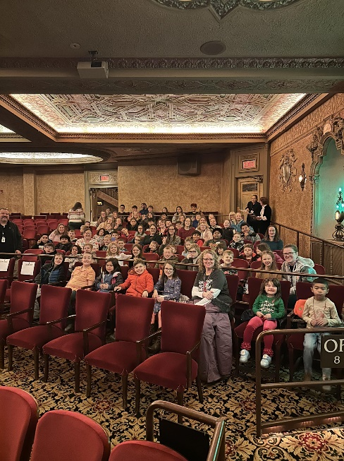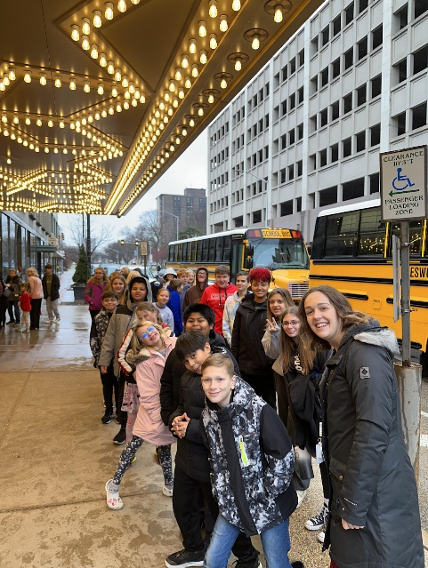

Winter Arts Night
We had such a fun time at our holiday concert and art walk! Elementary students sang popular Christmas songs including Santa Claus is Coming to Town, I Want a Hippopotamus for Christmas, and Sleigh Ride. Our band performed two pieces, one of which was Deck the Halls. Students dressed for the holiday occasion, and we even had our own Santa performing on stage!
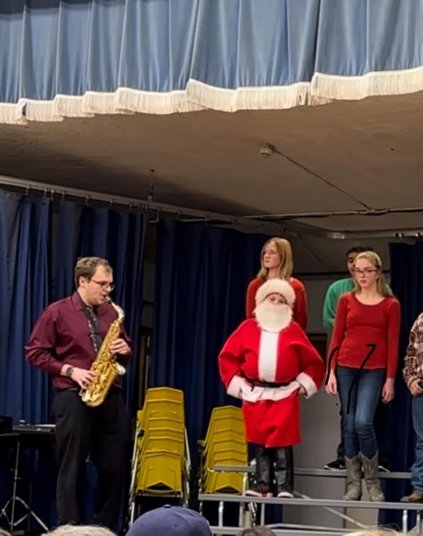
Mrs. Rittmeyer - Physical Education

Elementary classes have continued learning and demonstrating control when performing fundamental locomotor, non-locomotor, and manipulative skills. In doing so, we are playing many different whole-group games, improving ball-handling skills, and roller skating! We have enjoyed being able to go outside regularly this quarter.

Grades 5-8 have been focusing on health-related fitness, basketball, and roller skating. We spent our class time improving and learning skills, learning game rules and procedures, and learning how to be responsible for ourselves and to each other. Most days we are getting a bit of fresh air and activity outside, too. It was such a mild late fall/early winter.

Mrs. Hunter – K-8 Grade Art-We have had a busy quarter in Art with some seasonal projects, studying various artists and making art projects in their style, and getting ready for the Winter Arts Night. Some of the highlights were drawing and painting our own pumpkins and making our own Wiggly Watercolors after studying the artist Paul Klee in grades K-2. The 3rd/4th/5th graders enjoyed making their own Twittering Machines like Paul Klee and their own standing mobiles like artist Alexander Calder. The 6th-8th graders decorated a basketball hoop like artist Victor Solomon and made their own Starry Night after studying Vincent van Gogh’s style.
7th-8th Grade Careers-We continue to have speakers come in to tell the students about their jobs. Individual speakers frequently do this during class time on Wednesday mornings. We also had a Career Fair this grading period where four speakers came in and time was set aside throughout the morning for the students to learn about the speakers’ careers. The speakers have talked about jobs that require a high school diploma, trade school, or a college degree. It is our hope that this might introduce the students to a career that they might want to investigate further and help them know what classes to take in high school if they decide to pursue this career.

