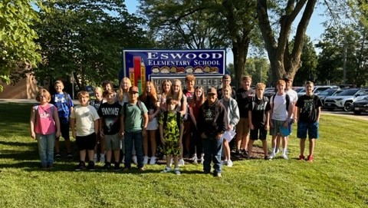
October 2023

Hello to our Eswood Community & Families,

We have had an absolutely wonderful start to the school year. Our staff has been tirelessly working on our new curriculums building great lessons and relationships with their students!!! We have welcomed new teachers, Mr. Larson-4th grade, Ms. Dobson-5th Grade and Mrs. Tofte moved to our Middle school science position.

Our volleyball team came in 3rd at the Meridian Conference Tournament that Eswood hosted October 11th and 12th. CONGRATS to all the volleyball players, it was obvious that their skills grew tremendously this season!
Our Boys’ basketball team has home games November 2nd, 9th, 30th and December 12th. Games begin at 5:30pm, come on out and support our LIONS and watch our Eswood Cheerleaders. We will recognize all of our 8th grade boys’ basketball players and cheerleaders on November 30th.
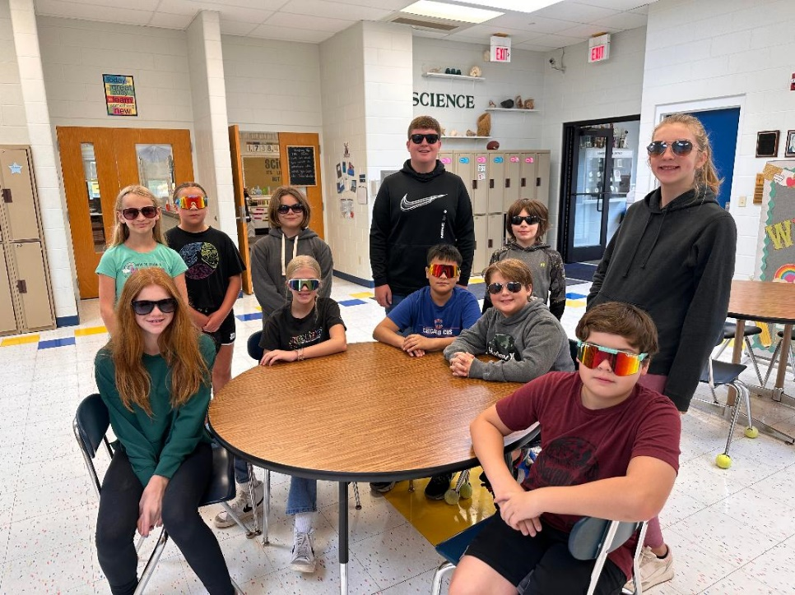
Mrs. Reed and Mr. Larson were nominated by the Shearer family and won the School Staff Superstar award in October and they were celebrated and recognized by Will’s Chiropractic and showered with gifts. If you see either of these ROCKSTAR teachers let them know how much they are appreciated!!!

Our middle school students took a field trip to see the WWII days at Midway Village and loved every minute of that time!!! I was told that our students were extremely well behaved and were very interested and asking great questions!
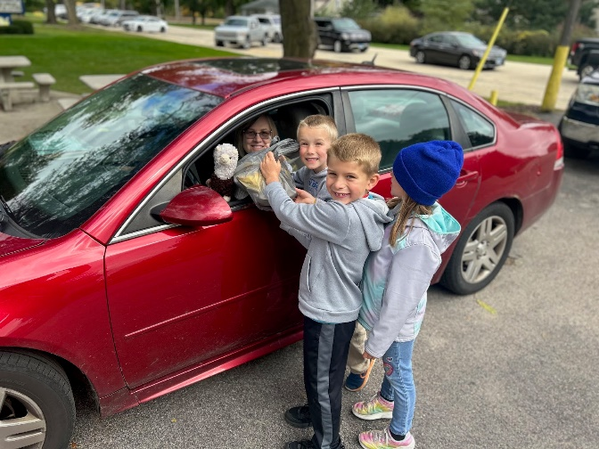
Eswood has had some building improvements made, with some roof work, new flooring in two middle school classrooms, new water, new electrical work and some work in our vault.

Community Club and the Eswood Education Foundation have supported our staff in many ways already this year with the Community Club getting new spirit wear shirts for all staff, supplying dinner for our fall conferences, and hosting the infamous Pork Chop dinner this fall already. The Foundation has approved teachers grants to support many different pieces of our school, along with $3,000 worth of musical instruments for our music room!! Thank you, thank you, thank you for all these wonderful extra enrichment items to support our school and our students. We are very blessed here at Eswood to have a community that supports us in the manner that they do!!!!

Mark your calendars for our Eswood Art’s Night on Wednesday, December 13th starting at 5:30pm with an ARTS WALK & cookies, and then a Winter Concert at 6pm.

Enjoy the wonderful fall weather and upcoming & holiday season!!

Sincerely,
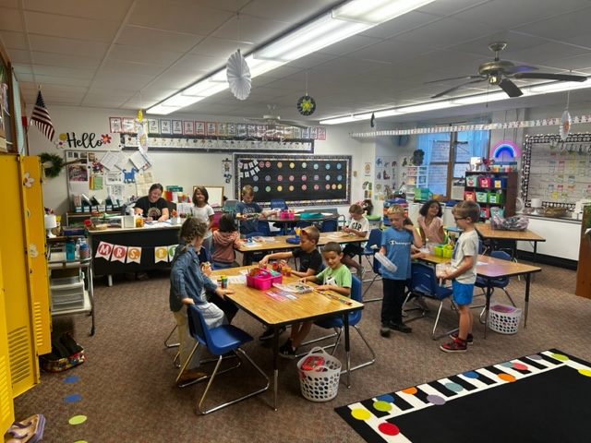
Kirsten Garrigan
Eswood Superintendent

In the Classrooms…

Mrs. Rogers- Quarter 2 started this week. What a fun 1st quarter we have had! I have enjoyed getting to know all your children and am starting to see their fun personalities come out more and more each day! They have been working so hard learning our rules and routines and have done a great job doing the work that comes with our curriculum! I am so proud of how far they have all come so far and I can’t wait to continue to watch them grow as we go throughout the school year!
The students have been working on learning letters and their sounds in phonics. Also in phonics, students have been working on blending sounds together to read simple words. Students have also started to learn their irregular words (words that either can’t be sounded out or where a letter is making a sound that they haven’t learned yet). In math, we have been working on our numbers from 0-10. Students have been practicing how to write those numbers and practicing counting by 1s to figure out how many objects are in a group. During writing, students have started learning how to write their D’Nealian letters. I am so excited to see what Quarter 2 brings with the students’ growth!

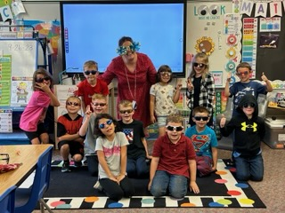
Mrs. Reed - The first quarter of First Grade has been busy and fun! First graders have been learning new routines, procedures, and expectations, as well as new academic content. We have reviewed our kindergarten phonics skills and branched out to more sentence writing and journaling. We know the difference between nouns, verbs, and adjectives, and we are starting to use them in our writing. First graders are quickly turning into experts in addition and subtraction, even of up to three numbers! We have been studying the needs of animals for survival and learned all about maps and the communities we are part of. We have been soaking up the last of the mild weather by enjoying snack time and recess outdoors.

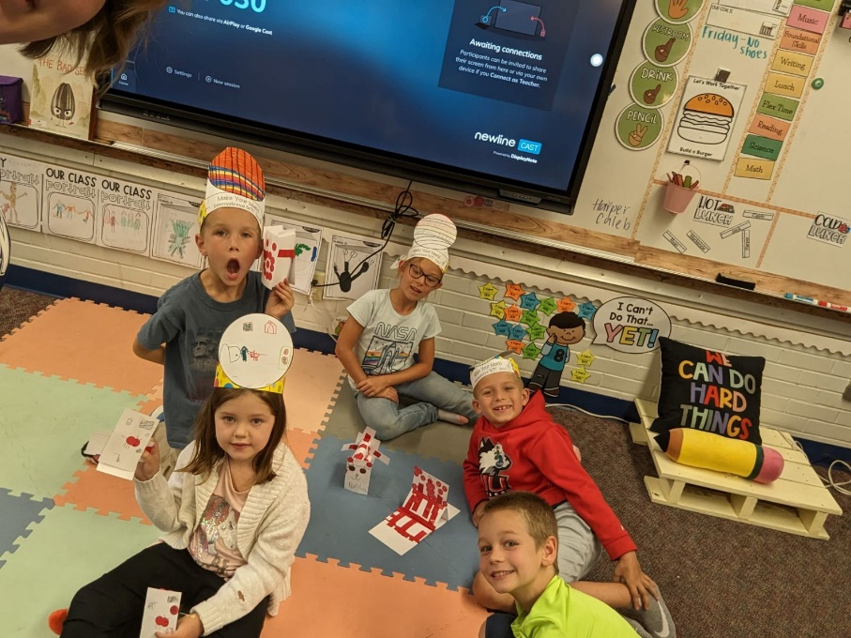
Miss Hosick – Hello from second grade!
It is hard to believe that we are already two months into the school year. This year has already been filled with some much learning and growing together as a classroom community.
Math - In math, students have applied and built their knowledge of place value.
Reading - We already read some many wonderful books. One of our favorite books has been Meeting the Dog of Bedlam Farms by Jon Katz. In our first reading unit we talked alot about what it means to be a good citizen. Currently we are wrapping up our fairytale unit. Pictures to come!
Writing - Students are currently working on crafting their own fairy tales. They are so creative and some much fun to read!

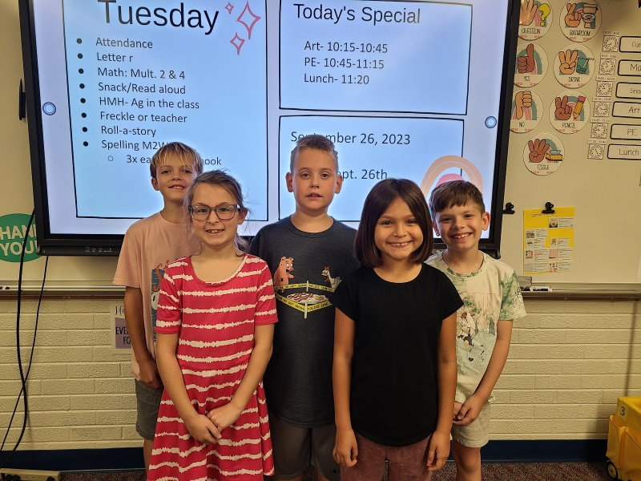
Mrs. Bell – What a wonderful first quarter here in 3rd grade! Your kiddos are rocking so far this year. I am overjoyed that I get to be a part of your school community again this year. Let’s jump into what your children have been learning so far this year.
In handwriting we are working our way through the alphabet. Students are learning correct formation of letters and applying that knowledge in forming word parts and words. We are a little over half way through the lower-case letters. We will continue to work through the rest of the alphabet lower case to upper case and then move on to more challenging skills.
Math started with some review skills from 2nd grade. We worked on addition and subtraction review early in the quarter. Now we are focusing on the most important skill of 3rd grade, multiplication! We started off conceptually using pictures, making groups, and drawing arrays. Then we went into the properties of multiplication and looked at the facts in different ways. My goal is to have kids start to memorize the multiplication facts and work on them throughout the year.
Since the start of the year in ELA (reading, writing, grammar, spelling) our focus was whole group instruction using the new curriculum. The main focus was on comprehension skills, sentence structure, and spelling patterns. We just started reading “Because of Winn Dixie” together as a class and should finish it in the next couple of weeks.
In science we have had the opportunity to try a couple different experiments to build on their understanding of force. The kids really enjoyed getting to experiment on their own. Our focus in social studies has been on government and civics. Learning about different types of government and how our government works. We also looked at how each person can be a good citizen.
I hope that your child has shared some of those fun things with you so far. I am excited to see what fun we will have next quarter!

Mr. Larson – 4th Grade is off to a great start as I begin my first year here. I would first like to thank everyone, from the students and parents to the administration and staff for making this such an awesome experience. Eswood has been such a welcoming and positive environment. The students are so enthusiastic and excited to jump into the school year. We are aggressively pursuing long division, two-digit multiplication and four-digit subtraction in math. In English language arts we have been working on reading fluency, as a group we have voracious readers who continue to acquire AR points on a weekly basis. We have created some amazing writing pieces about Halloween and some 'scary' stories, focusing on plot development and figurative language. I am absolutely thrilled to be here and look forward to what the future holds for our 4th graders!

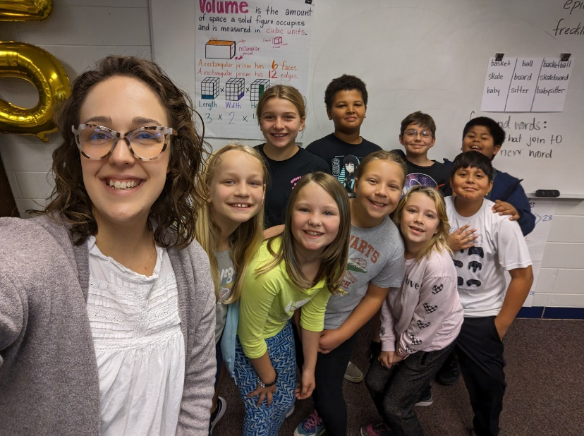
Ms. Dobson - Hello from fifth grade! We have officially made the old computer lab our home sweet classroom, and we enjoyed lots of learning in the first quarter.
Mathematically, we worked towards mastery in applying our place value knowledge to multiply multi-digit factors and divide 3-digit dividends by 2-digit divisors. It’s really no joke that long division is long, but students enjoyed the gratification that comes with persisting in solving for the quotient. We are also about to finish our module on volume, so if you see a fifth grader walking around, feel free to ask them to calculate the volume of any right rectangular prisms you have laying around.
During English Language Arts, our first two modules sought to answer the following essential questions:
- What kinds of circumstances push people to create new inventions?
- How does genre affect the way a story is told?
We read many different texts, and some of our favorites were Captain Arsenio, Airborn, and The Miracle of Spring. In addition, we authored expository essays about preserving inventors and narrative stories crafted as either science fiction or fantasy.
In Social Studies, we’ve learned about the structure of the United States government, the historical origins of various forms of government, and characteristics of U.S. and world regions. The students are also enjoying their time with Mrs. Tofte in Science.
We are looking forward to the holiday season together and anticipate lots of learning in the year to come!

Mrs. Tofte- (6th Math, 5-8 Science)
I am shouting, "Hi!" from the Middle School side this year, Middle School Science to be exact. All science classes began this year with an overview of the Crosscutting Concepts of science (scales, proportion, quantity, patterns, structure, function, energy, matter, stability, change, cause, effect, systems, and system models). The students quickly realized that science is woven into almost every aspect of their daily lives. Next, we took a deep dive into constructing Scientific Arguments using the C.E.R (claim, evidence and reasoning) format to express and support their research and ideas.
Fifth grade science is currently analyzing the Patterns of Earth and Sky using our new Amplify Curriculum. The students have been able to gain a deeper understanding of the day and night sky using numerous simulations as well as by creating small scale models. We have analyzed constellations and different reasons as to why we see certain ones at certain times.
Sixth through Eighth sciences are also working with the new Amplify curriculum. The students are examining different types of energy and ways that energy can be stored and converted. We have worked with hands-on equipment such as solar panels and hand crank generators to power small motors in order to spin a fan. The students then compared the effectiveness of the different energy systems. Currently they are exploring ways to harness human energy through movement in order to power a flashlight and small devices. While working in groups, the students have designed and built prototypes of their unique energy devices that they will later present to the class. Along with designing and constructing their energy devices, eighth grade is preparing to film a persuasive commercial using Ethos, Pathos, and Logos to "sell" their devices.
I would like to thank the Eswood Education Foundation for granting the science department the funds to purchase a 3D printer. We are excited and anxious to use this new tool to further the students' learning.
In Sixth grade Math, we started the year with rational numbers, inequalities, and positive and negative numbers using the HMH Into Math Curriculum. Currently, the students are working on adding, subtracting, multiplying and dividing decimals to the thousandths place.
It has been an amazing start to the school year and I am excited to watch the students continue to learn and grow.

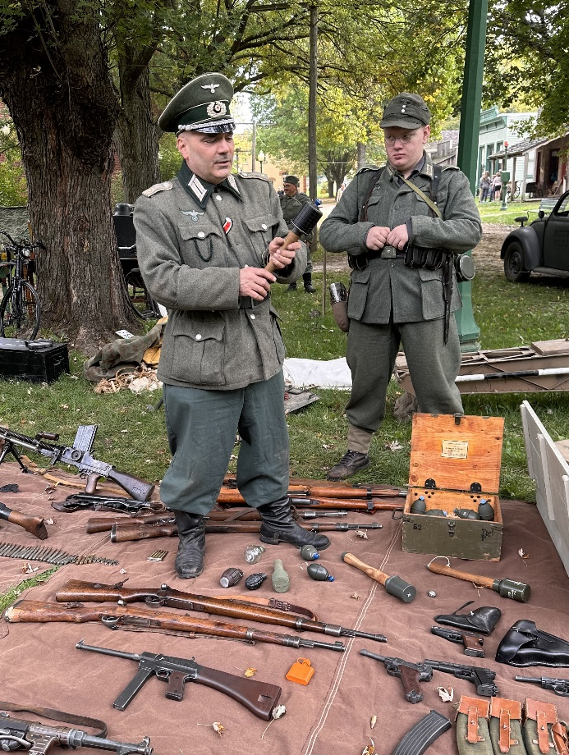
Mrs. DeHahn - I can't believe it is the end of the first quarter already! We have all settled in on the middle school end of the building. Sixth, seventh, and eighth grade students have been reading short stories from their literature books, reviewing grammar, and writing responses to literary analysis. The eighth-grade students also wrote a persuasive/expository essay for a Patriot's Pen essay contest. The students enjoyed a book tasting party at the beginning of the year. They were introduced to books of several different genres such as: mystery, horror, poetry, biography, realistic fiction, historical fiction, and science fiction. The students enjoyed a field trip to Midway Village where they learned about World War II.

Mr. Winters - In math, the 7th graders focused on recognizing proportional relationships in tables, graphs, and scale drawings, plus finding unit rates and solving rate problems. They are now using proportional reasoning with percents. The 8th graders began the year solving multi-step linear equations, then shifted to exploring angle relationships with parallel lines, transversals, and triangles. They are now learning about slope and functions. In 6th grade social studies, students were introduced to the tools of historians and geographers, then began developing an understanding of how civilizations started and became more complex. Both 7th and 8th grades initially began learning and reviewing the themes and tools of historians and geographers, plus the foundation layers of our nation and government. However, they will soon head in diverging directions of our country's timeline (Pre-/Post-Civil War). The 6th, 7th, and 8th grades all worked on a "Food" project presentation, ask them to share with you! Let's have a great second quarter!

Ms. Rittmeyer - Physical Education has been a whirlwind of activities and hopefully a lot of fun!

Elementary classes have been learning and demonstrating control when performing fundamental locomotor, non-locomotor, and manipulative skills. In doing so, we are playing many different whole-group games. We spent some of our class time throwing and catching, jumping rope, kicking balls, and balancing on different bases of support. We have enjoyed being able to go outside regularly this quarter.
Grades 5-8 have been focusing on health-related fitness, volleyball, and football. We spent our class time improving our skills, learning game rules and procedures, and learning how to be responsible for ourselves and to each other. Most days we are getting some fresh-air and activity outside, too!

Mrs. Hunter - We have enjoyed working on art projects during the first quarter that illustrate the Elements of Art: Line, Color, Shape, Value, Form, Space, and Texture. Here are a few of the projects that we have completed during the first grading period. The kindergarteners used primary colors to paint with different textures. The 1st/2nd graders painted with secondary colors. The 3rd/4th/5th graders made collages by cutting objects out of textured paper that they had painted. The 6th graders made and decorated pyramids to show form. The 7th/8th graders put it all together when they made collages that showed line, color, shape, space, and balance.

We look forward to learning about some famous artists and their styles, creating some seasonal artwork, and working on some other fun projects in the coming weeks.

Mr. Groth – New Instruments
The Eswood band program was fortunate enough to receive a grant from the Eswood Education Foundation to purchase new instruments! Some of the purchases include trumpets, flutes, a French horn, a wooden xylophone, and much more percussion equipment. Thank you to Mr. Newkirk and the whole Eswood Education Foundation! We look forward to using these instruments for future performances and concerts.

MusicPlayOnline
The general music classes have been using a new platform for music class this year: MusicPlayOnline. This platform lets us make music to many different kinds of songs: folk songs, classical music, pop songs, and many more. Some favorite songs so far include: She’ll Be Comin’ Around the Mountain, Poor Little Bug, and Mountaintop Monster. We also get to learn about composers and musical elements such as dynamics, tempo, rhythms, and the music staff!

