Happy, Happy SPRING Eswood Families, March 2023
We have had a lot of academic activities taking place here at school during our third quarter.

Girl’s Basketball: Our girl’s basketball team had their season short on players. We were blessed with some 4th and 5th grade girls that were brave enough to join the team and work hard to build their skills. Hopefully this season was a springboard to building our girl;s basketball program!

Charlie and the Chocolate factory Musical: We had a group of our Eswood students take a field trip to Hononegah to see a presentation of Charlie and the Chocolate Factory in early February. The students had a blast and talked about how great the show was.

Literacy night: The Eswood-Student Council Literacy Night, where students came and enjoyed an evening of reading, crafts, treats and went home with a book of their choice, sponsored by the Eswood Education Foundation.

Students name the Eswood Mascot: The school had a contest to name the LION mascot for our school. After a few rounds of voting, the school came to the decision that our school mascot would be named LERRRROY THE LION!

Speech: We had a handful of middle school students that faced their fears and became a part of the Eswood Speech team, participating in two meets in March and ALL STUDENTS placed!!! CONGRATULATIONS for all your hard work and Thank you to Mrs.DeHahn for coaching these individuals!

Testing: Eswood 3rd-8th graders have finished their Illinois Assessment of Readiness (IAR) test. We tried to have a little fun this year and had pep assemblies, a kick-off breakfast, prizes and treats throughout the few weeks of preparation and testing. Students won prizes from games, basketball and volleyballs to bluetooth speaker and earbuds and Ice-Hog and bowling tickets, as well as some Eswood swag from Bee Designs. Our kindergartners, 1st and 2nd graders provided the test takers with support from encouraging notes, locker sign and cheers at our pep assembly. Everyone worked very hard to make this testing time a bit more fun and rewarding for the students. The 5th and 8th graders will have a State Science Assessment mid-April to assess their science knowledge, as well.

Steam Night: Mrs Tofte and our staff have put together our AWESOME Discovery Center STEAM night that over 100 people participated. The students were able to actively learn, while creating hands-on projects in the areas of Science, Technology, Engineering, Art and Math!!! THANK YOU to Community Club for providing concessions and the Eswood Foundation for sponsoring the event!! Another great enrichment activity for our students!!! We were also able to extend this event to surrounding schools and many of them had students attend along with our kids! What a great way to get to know other students in our area!!!

Chess: Eswood will be holding our Annual Chess Tournament on April 20th at 4pm, Community Club will once again over concessions for families. We have over 100 students set to come and engage their brains in a great game! Thank you to Mr Winters for organizing the event and coaching and preparing our Eswood students for the tournament!

We have a lot of upcoming, end of the year events we will see during the 4th quarter. Please check out our website for the dates and times. https://www.eswoodschool.org/ Track will start soon after break, we have the 8th Trip & graduation, Middle School Awards, K-2 Butterfly field trip, last day of school School-wide Bowling. SO MUCH exciting activities before we close out this school year.

Thank you for allowing me to lead this amazing school!
I am blessed beyond measure to have the opportunity to be a small part of your children’s lives.

Sincerely,
Kirsten Garrigan
Principal/Superintendent (In Training)

In the Classrooms…

Ms. Cooley- We have entered the final quarter of the school year! We have started focusing and talking about how the students can best prepare for first grade! In math during quarter 3, students finished up the addition and subtraction modules. We learned counting to 100 by 1s and 10s. Students finished off the quarter by learning about 3d and 2d shapes. In phonics, students have now worked with all consonant and short vowel sounds (long vowel sounds will be in quarter 4). They also started to learn about consonant blends at the beginning and end of words. In reading, students have now learned over half of their reading words. They are all doing so good at recognizing and remembering the words they learned this year!

Mrs. Reed - First grade has been hard at work all through the third quarter! In math, we have learned how to organize data into picture graphs, bar graphs, and tally charts. We have sharpened our place value skills, and are able to represent numbers up to 120 using place value block drawings. We have been pushing our phonics skills past simple vowel sounds, and we can now encode words with several different vowel combinations. Our first graders completed an opinion writing piece featuring one of their favorite things, including an introduction, details, and a conclusion. We are looking forward to the Spring as we gear up for an extensive study about butterflies and their life cycle, leading up to our May field trip to the Nicholas Conservatory!

Miss Hosick – Goodbye third quarter! Here in the second grade room we have been busy bees!
Math - One of our highlights this quarter was transforming our classroom into a cafe so we practice our money skills. Another highlight was learning how to tell time so now we are never late for lunch!
Reading - In reading we are applying many different kinds of skills to books that are leveled for each student. However, our favorite part of march was our book bracket! We got to vote on 16 read a louds to see which was our favorite! Salt in His Shoes Won! You should read it!
Writing - Students have practiced writing personal narratives and procedural texts. It is wild to see how their writing has improved from the beginning of the year to now!
Science - In science we have been learning about how the Earth goes through slow changes like erosion and fast changes like volcanos.
Social Studies - During social studies we have started our Geography unit. To learn a little more about the world around us we read the book Flat Stanley. We make our own Flat selves and sent them to our friends and family to explore the world.

Mrs. Bell –Third quarter was tough, but showed how resilient our students were. This was the first time students were a part of the state testing requirements. There were many skills we did not get to but everyone did their best! I am proud of our third graders.
We learned a lot during third quarter. In math, we continued to work on multiplication and division. Before testing, we focused on reviewing skills and navigating the testing platform. We played games, a class favorite is Blooket, which they ask to play all the time now! I also celebrated Pi Day with the class, bringing in pie for them to have.
After winter break we started reviewing our reading skills to prepare for the IAR test. We reviewed stories that we previously read and looked at different types of testing questions. We also did two writing units; opinion and persuasive writing. Boy, is this class a group of good writers!
In science we have been learning about animals and habitats. I am so excited to share that we are having chicks coming soon! I look forward to teaching the kids about the life cycle and watching it live in class. In social studies our focus has been on geography. We have learned about the five themes of geography and will continue to learn about those during part of the fourth quarter.
We are down to our last quarter of learning! I continue to be amazed by the abilities of these students, how much they learn and grow. I can’t wait to see what we accomplish before the end of the year.

Mrs. Tofte- It’s hard to believe we are in the home stretch of the 2022-2023 school year. This year is just flying by! Here is a quick overview of what we have done this quarter.
Reading- The fourth graders have finished their Genre Study where we dug deep into Nonfiction and Fiction texts. The students focused on concepts related to Informational Texts, Biographies, Argumentative Texts, Realistic Fiction, Traditional Tales, and Historical Fiction. They have continued to practice the skill of analyzing a text through different lenses such as: point of view, plot events, character traits, and the use of Figurative language.
Math- The students continue to work towards mastery of their basic multiplication and some are even ready for division facts! Modules on multiplying 2-digit numbers, dividing by 1-digit numbers, factors, multiples, and patterns have been completed. The students ended the Module with a large project where they designed a vacation of a lifetime for a chosen celebrity. To complete the project, they had to choose a destination, find plane tickets, hotel accommodations, activities, and prepare a menu while sticking to a budget. The class had a great time navigating travel websites and learning how to budget while using their multiplication and division skills. Currently, the class has started working with the area of combined rectangles.
Writing- The students are continuing to work with a 4-Square outline in writing to organize their thoughts and ideas. We have finished our Opinion Writing and the students have just begun the outline for their Persuasive Essays. They will be creating their own monsters and then writing an essay to persuade buyers to buy them.
Social Studies/Science- This quarter, we focused more heavily on Social Studies than Science. In Social Studies we wrapped up our unit on Geography where the students learned to work with and interpret different types of maps. The students also had a chance to examine the different Regions of the United States and what boosts the economy in each region. Science will be the focus for the 4th Quarter, and we are currently working on Structure, Function, and Information Processing.
These last couple of months will be packed full of learning! Please continue to work on math fact cards and spelling words.
I have truly enjoyed my second year at Eswood and I am incredibly grateful to be a part of such a supportive community. Thank you to all the parents and students for a great year. I hope you all enjoy your Spring Break!

Mrs. DeHahn - The fifth and sixth grade classes enjoyed STEAM class. They made bristlebots, marble runs and mazes, and painted with shaving cream. In language arts class, they completed a descriptive writing unit. They drew and described their own gingerbread houses that they were trying to sell. They also wrote an argumentative essay responding to two different texts that they read. The seventh and eighth grade classes were busy writing argumentative essay responses. They also continued reading short stories in their literature books. The seventh-grade class finished a unit on stories, poems, and essays about space, and the eighth-grade class started reading The Outsiders by S.E. Hinton.The students worked very hard on their IAR testing that took place in March. They also had fun voting on their favorite books in our own March Madness at the middle school end.

Ms. Eden -Fifth Graders studied the properties of matter. They learned about the properties of matter and
applied what they learned using the engineering design process to mix substances to create new substances to repair a pothole. This Quarter they will learn about Matter and Energy in Organisms and Ecosystems. Fifth graders will also learn about Earth Systems and Space Systems: stars and the Solar System. Sixth Graders explored the different types of rocks and how each type is formed, their
characteristics and the various stages of the rock cycle. This Quarter students will learn about Body Systems including Cells, and tissues and organs and how they connect and specific body systems. The Seventh Graders have finished their research and study of earthquakes and volcanoes. This quarter they will study ecosystems and Ecology.create scale models of the earth, three types of earthquake faults, and build an earthquake proof structure. This quarter Eighth Graders researched and studied DNA and genetics. Students are still transforming our gummy bear wave model into a strand of DNA. Following their study of Genetics and Fossils eighth graders will study Space Science. We are looking forward to the visit of the inflatable StarLab planetarium in April to enhance this unit of study.

Mr. Winters –In third quarter math, 5th grade students wrote and evaluated numerical expressions, including the use of grouping symbols, and learned to find the volume of right rectangular prisms (ask them to find the volume of a box!); 6th graders examined the four main operations using multi-digit decimal numbers, ratios, unit rates, and their potential use in real world situations; 7th grade used the four main operations with rational numbers (+/- fractions, decimals, combinations), this also included real world situations; 8th graders explored understanding and analyzing functions and solving systems of linear equations. In Social Studies, 5th/6th grades focused on various empires/kingdoms of the African continent, while the 7th/8th graders examined the formation of the "American Identity", the lead-up, and beginning of the Revolutionary War. In STEAM, students made and floated paper boats, built cardboard skate parks, answered how they would spend $1,000,000, researched and made a presentation on buying a car, and began working on balloon cars. Have a great Spring break!
Ms. Rittmeyer – Computer Classes continued learning how to effectively use Google. Our youngest students are learning about the various formatting options within “Slides” and “Docs” while our older students are learning the most efficient ways to search for information and organize files. Also, Middle School students did some “Career Cruising” by completing various assessments regarding personal interests and skills.
Social and Emotional Learning (SEL) classes have focused on Problem Solving skills. The STEP approach was learned. S Say the Problem T Think of Solutions E Explore the Outcomes P Pick a solution to resolve the problem
Physical Education classes recently completed a Bowling unit. Thanks to T-Byrd Lanes of Rochelle for the equipment use!
K-2 classes have continued learning about and strengthening their Fundamental Motor Skills while playing listening games, Parachute games and ball handling (foot and hand).
Grades 3 & 4 added to the above with Pickleminton, indoor soccer, speed cup challenges, 4 Square, pingpong, and air hockey variations.
Grades 5-8 have continued strength training by participating in a rotation of endurance and strength exercises. Students also completed the following units: pickleball, floor hockey, indoor court games, and kickball.

Speech - The Eswood School Speech Team completed their 2023 season competitions with much success. The team consists of Kaylee Horner, Camden Alsup, Brayden Bowers, and Cheyenne Somers. They are coached by Mrs. DeHahn. The season began with a competition on March 7th at the Rochelle Middle School. All four students placed in three different categories. In Novice Prose Camden Alsup placed 5th, and Kaylee Horner placed 6th. In Varsity Verse, Cheyenne Somers placed 5th while Brayden Bowers placed 2nd in Varsity Radio. The second competition on March 14th was even more successful! All students placed in every category they competed in at RTHS. In Novice Prose Camden Alsup placed 3rd, and Kaylee Horner placed 6th. In Novice Verse, Camden Alsup placed 1st. Cheyenne Somers placed 6th in Varsity Verse while Brayden Bowers placed 2nd in Varsity Radio. Congrats to these four students who put in several hours of practice and dedication to the craft of public speaking. Also, thank you to the parents and other family members that have supported these four wonderful students! It’s a great day to be an Eswood Lion!

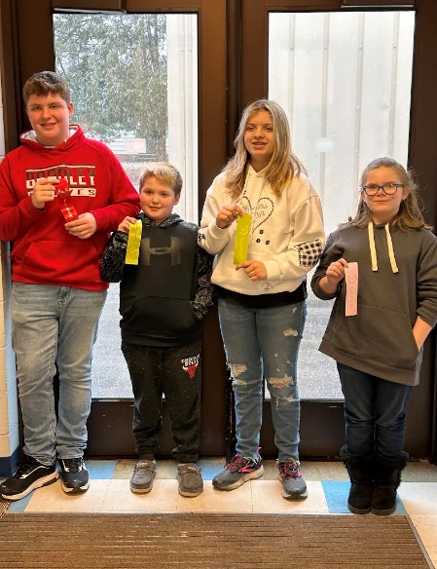
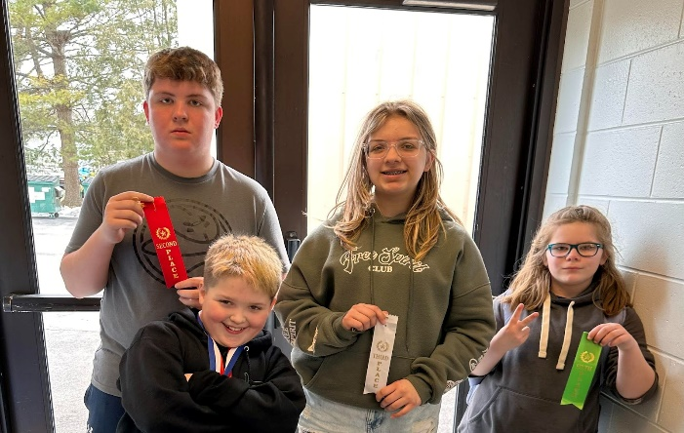

Eswood Community Club

The Eswood Community Club wants to express our thanks to the families who have participated in our activities this year. We have enjoyed seeing the families who have participated in our Breakfast with Buddies, Cookies and Cocoa, and Family Movie Night. These events could not be made possible without the monetary support of our students’ families and friends through our fundraisers and support of the concession stand at school events. We appreciate all that you do to ensure the success of these events each year.

Through our fundraising efforts this school year, we have helped to fund roller skating in PE, additional books for the library, staff meals during parent/teacher conferences, Eswood apparel for our hard working teachers, grant requests for classroom materials, and STEAM night. We purchased a new popcorn machine after ours met its unfortunate end and purchased a snow cone machine to be used for classroom parties and incentives.

The Community Club would also not be able to function without its volunteers. A huge thank you to everyone who has helped at the concession stand or at family events this year. In addition, thanks to the Eswood Staff, Mrs. Garrigan, and parents for attending meetings each month. Also, thank you to Annie, Carrie, and Brandi for their service on the Community Club board and Annie as the concession stand manager.

We will be in need of volunteers for the Chess Meet on 4/20. Please see our Facebook page for a link to the signup sheet.
Check out our Facebook group: Eswood Community Club for future meetings and volunteer opportunities. You can also email communityclub@eswoodschool.org to be added to our email list.

